The School of Engineering Technology and Applied Science



**COMP214**

**Advanced Database Concepts**

**Term project**

**Submitted to:**

Professor Vijayalakshmi Tiruchengode Angamuthu (Viji)

Salary Management System

Submitted by:

**Kelly Tan(300991647) Simranjeet Kaur(300988063) Tariqule Hasan Khan(300883293)**

Table of Contents

1 ER MODEL (Salary Management System)........................................................................................................................................................ 3

2 Business Rules.................................................................................................................................................................................................. 4

3 DESCRIPTION OF TABLES GENERATED!!!.......................................................................................................................................................... 4

4 SQL code for generating table and queries:!!!............................................................................................................................................... 24

**ER MODEL (Salary Management System)**

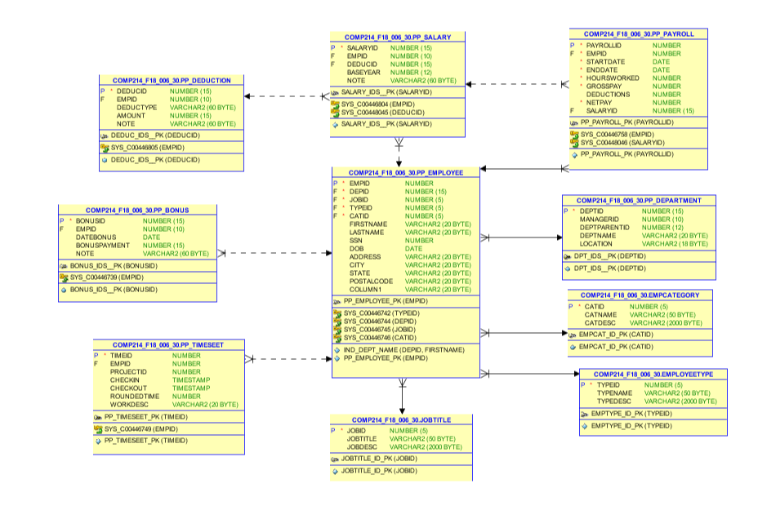

**BUSINESS RULES:**

* Each employee can receive one or more salaries and bonuses. Each particular salary belongs to one and only one employee. Each bonus belongs to one and only one employee.
* Each salary must receive one and only one deductions. Each deduction is associated with one or more salaries.
* Each salary belongs to one or more payrolls. Each payroll can receive one and only one salary and one employee. Each employee can receive one or more payrolls.
* Each employee can be associated with one or more time seeds. Each time seed is associated to one and only one employee.
* Each job title can be associated to one or more employees. Each job title is associated to one and only one employee.
* Each employee is in one and only one department. Each department can have one or more employee.
* Each employee belongs to one and only one employee category. Each employee category can have one or more employee.
* Each employee belongs to one and only one employee type. Each employee type can shave one or more employee.

**DESCRIPTION OF TABLES GENERATED!!!**

Table name – Employee (Tariq)

|  |  |  |  |  |
| --- | --- | --- | --- | --- |
| Attribute | Description | Key Type/  Constraint | Data Type | Filed length |
| user_id | Used to login into the online system | Primary Key | number | 10 |
| First_Name | First name of the user |  | Varchar2 | 15 |
| last_name | Last name of the user |  | Varchar2 | 15 |
| gender | Male or female user |  | char | 1 |
| age | Age of the user |  | number | 3 |
| Mobile-number | Contact number if user |  | number | 10 |
| email | Contact mail of the user |  | Varchar2 | 50 |
| City | Locational city of the user |  | Varchar2 | 20 |
| Pin_code | Postal code for the location |  | number | 6 |

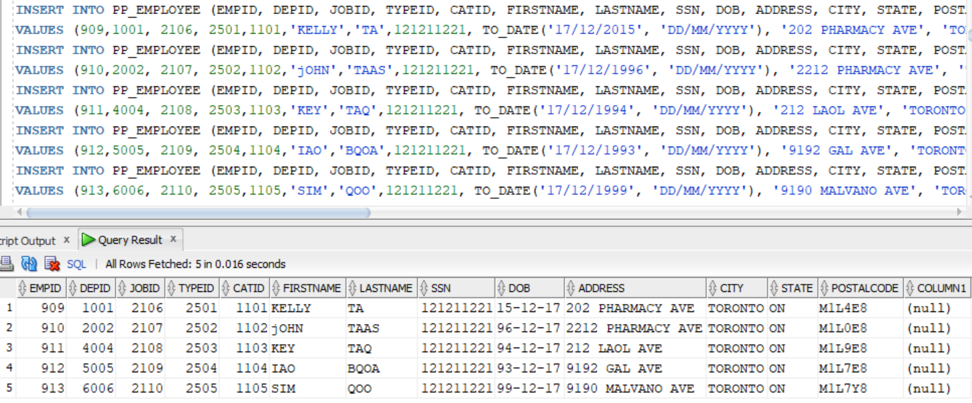

CREATE TABLE PP_EMPLOYEE

(

EMPID NUMBER NOT NULL

, DEPID NUMBER NOT NULL

, JOBID NUMBER NOT NULL

, TYPEID NUMBER NOT NULL

, CATID NUMBER NOT NULL

, FIRSTNAME VARCHAR2(20)

, LASTNAME VARCHAR2(20)

, SSN NUMBER

, DOB DATE

, ADDRESS VARCHAR2(20)

, CITY VARCHAR2(20)

, STATE VARCHAR2(20)

, POSTALCODE VARCHAR2(20)

, COLUMN1 VARCHAR2(20)

, CONSTRAINT PP_EMPLOYEE_PK PRIMARY KEY

(

EMPID

)

ENABLE

);

INSERT INTO PP_EMPLOYEE (EMPID, DEPID, JOBID, TYPEID, CATID, FIRSTNAME, LASTNAME, SSN, DOB, ADDRESS, CITY, STATE, POSTALCODE)

VALUES (909,1001, 2106, 2501,1101,'KELLY','TA',121211221, TO_DATE('17/12/2015', 'DD/MM/YYYY'), '202 PHARMACY AVE', 'TORONTO','ON','M1L4E8' );

INSERT INTO PP_EMPLOYEE (EMPID, DEPID, JOBID, TYPEID, CATID, FIRSTNAME, LASTNAME, SSN, DOB, ADDRESS, CITY, STATE, POSTALCODE)

VALUES (910,2002, 2107, 2502,1102,'jOHN','TAAS',121211221, TO_DATE('17/12/1996', 'DD/MM/YYYY'), '2212 PHARMACY AVE', 'TORONTO','ON','M1L0E8' );

INSERT INTO PP_EMPLOYEE (EMPID, DEPID, JOBID, TYPEID, CATID, FIRSTNAME, LASTNAME, SSN, DOB, ADDRESS, CITY, STATE, POSTALCODE)

VALUES (911,4004, 2108, 2503,1103,'KEY','TAQ',121211221, TO_DATE('17/12/1994', 'DD/MM/YYYY'), '212 LAOL AVE', 'TORONTO','ON','M1L9E8' );

INSERT INTO PP_EMPLOYEE (EMPID, DEPID, JOBID, TYPEID, CATID, FIRSTNAME, LASTNAME, SSN, DOB, ADDRESS, CITY, STATE, POSTALCODE)

VALUES (912,5005, 2109, 2504,1104,'IAO','BQOA',121211221, TO_DATE('17/12/1993', 'DD/MM/YYYY'), '9192 GAL AVE', 'TORONTO','ON','M1L7E8' );

INSERT INTO PP_EMPLOYEE (EMPID, DEPID, JOBID, TYPEID, CATID, FIRSTNAME, LASTNAME, SSN, DOB, ADDRESS, CITY, STATE, POSTALCODE)

VALUES (913,6006, 2110, 2505,1105,'SIM','QOO',121211221, TO_DATE('17/12/1999', 'DD/MM/YYYY'), '9190 MALVANO AVE', 'TORONTO','ON','M1L7Y8' );

Table name – Payroll (Tariq)

|  |  |  |  |  |
| --- | --- | --- | --- | --- |
| **Attribute** | **Description** | **Key Type/**  **Constraint** | **Data Type** | **Field length** |
| Passenger_id | A unique identification number for passenger | Primary key | Number | 10 |
| User_id | Used to login into the online system | Foreign key | Number | 10 |
| Age | Age of the passenger |  | Number | 3 |
| Reservation_status | Information of reservation |  | Varchar2 | 2 |
| Seat_number | Seat information |  | Number | 3 |
| Ticket_id | Information regarding the ticket |  | number | 10 |

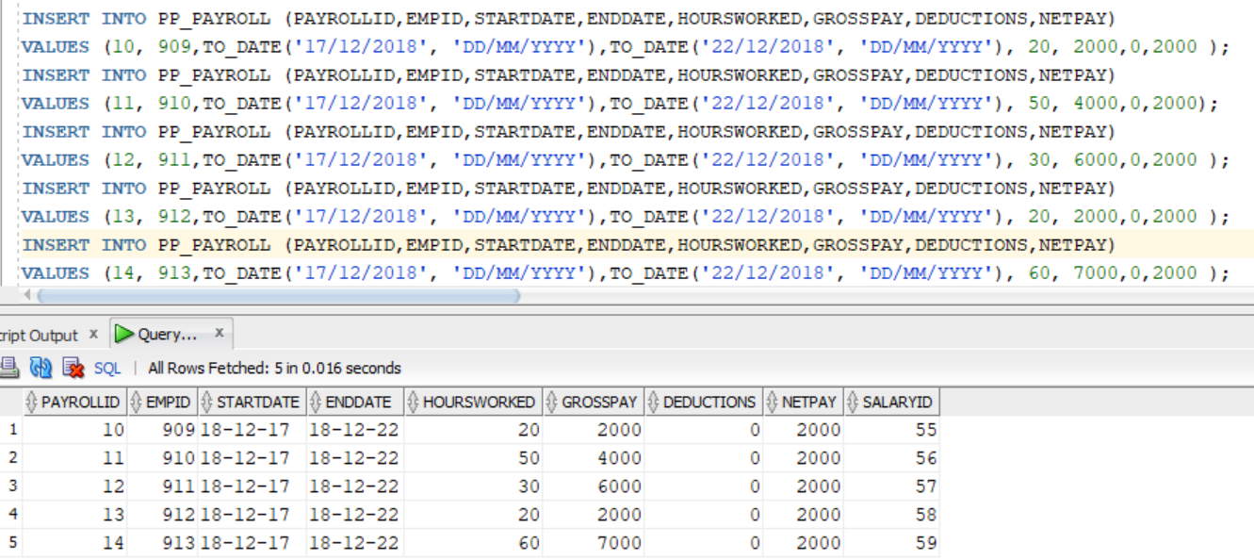

CREATE TABLE PP_PAYROLL

(

PAYROLLID NUMBER NOT NULL

, EMPID NUMBER NOT NULL

, STARTDATE DATE NOT NULL

, ENDDATE DATE NOT NULL

, HOURSWORKED NUMBER NOT NULL

, GROSSPAY NUMBER NOT NULL

, DEDUCTIONS NUMBER

, NETPAY NUMBER NOT NULL

, CONSTRAINT PP_PAYROLL_PK PRIMARY KEY

(

PAYROLLID

)

ENABLE

);

INSERT INTO PP_PAYROLL (PAYROLLID,EMPID,STARTDATE,ENDDATE,HOURSWORKED,GROSSPAY,DEDUCTIONS,NETPAY)

VALUES (10, 909,TO_DATE('17/12/2018', 'DD/MM/YYYY'),TO_DATE('22/12/2018', 'DD/MM/YYYY'), 20, 2000,0,2000 );

INSERT INTO PP_PAYROLL (PAYROLLID,EMPID,STARTDATE,ENDDATE,HOURSWORKED,GROSSPAY,DEDUCTIONS,NETPAY)

VALUES (11, 910,TO_DATE('17/12/2018', 'DD/MM/YYYY'),TO_DATE('22/12/2018', 'DD/MM/YYYY'), 50, 4000,0,2000);

INSERT INTO PP_PAYROLL (PAYROLLID,EMPID,STARTDATE,ENDDATE,HOURSWORKED,GROSSPAY,DEDUCTIONS,NETPAY)

VALUES (12, 911,TO_DATE('17/12/2018', 'DD/MM/YYYY'),TO_DATE('22/12/2018', 'DD/MM/YYYY'), 30, 6000,0,2000 );

INSERT INTO PP_PAYROLL (PAYROLLID,EMPID,STARTDATE,ENDDATE,HOURSWORKED,GROSSPAY,DEDUCTIONS,NETPAY)

VALUES (13, 912,TO_DATE('17/12/2018', 'DD/MM/YYYY'),TO_DATE('22/12/2018', 'DD/MM/YYYY'), 20, 2000,0,2000 );

INSERT INTO PP_PAYROLL (PAYROLLID,EMPID,STARTDATE,ENDDATE,HOURSWORKED,GROSSPAY,DEDUCTIONS,NETPAY)

VALUES (14, 913,TO_DATE('17/12/2018', 'DD/MM/YYYY'),TO_DATE('22/12/2018', 'DD/MM/YYYY'), 60, 7000,0,2000 );

ALTER TABLE PP_PAYROLL ADD SALARYID NUMBER(15);

DESC PP_PAYROLL;

UPDate pp_payroll set salaryid ='55' where payrollid= '10';

UPDate pp_payroll set salaryid ='56' where payrollid= '11';

UPDate pp_payroll set salaryid ='57' where payrollid= '12';

UPDate pp_payroll set salaryid ='58' where payrollid= '13';

UPDate pp_payroll set salaryid ='59' where payrollid= '14';

Table name - TimeSheet (Tariq)

|  |  |  |  |  |
| --- | --- | --- | --- | --- |
| **Attribute** | **Description** | **Key Type/**  **Constraint** | **Data Type** | **Field length** |
| Train_number | Number of the train | Primary key | number | 10 |
| Train_name | Name of the train |  | Varchar2 | 20 |
| Arrival_time | Time at which train arrives |  | Time | 10 |
| Departure_time | Time at which train departs |  | Time | 10 |
| Availability_of_seats | Available seats |  | number | 3 |
| Fare | Cost of the ticket |  | Number | 10 |
| Date | day of the bookings |  | Date | 10 |

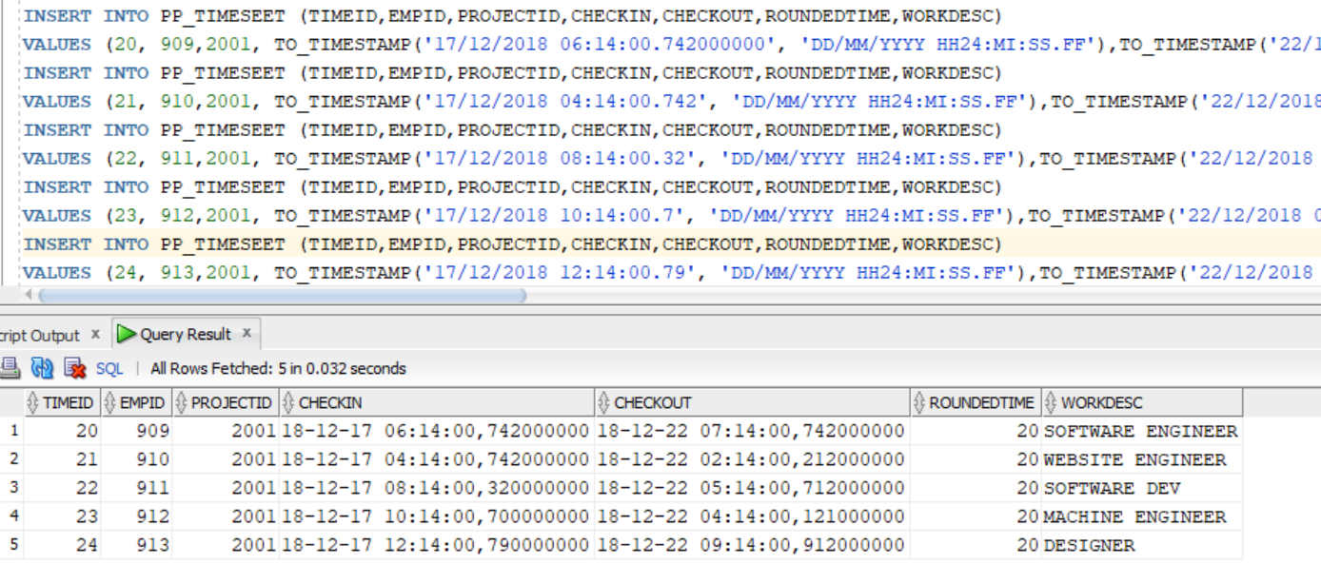

CREATE TABLE PP_TIMESEET

(

TIMEID NUMBER NOT NULL

, EMPID NUMBER

, PROJECTID NUMBER

, CHECKIN TIMESTAMP

, CHECKOUT TIMESTAMP

, ROUNDEDTIME NUMBER

, WORKDESC VARCHAR2(20)

, CONSTRAINT PP_TIMESEET_PK PRIMARY KEY

(

TIMEID

)

ENABLE

);

INSERT INTO PP_TIMESEET (TIMEID,EMPID,PROJECTID,CHECKIN,CHECKOUT,ROUNDEDTIME,WORKDESC)

VALUES (20, 909,2001, TO_TIMESTAMP('17/12/2018 06:14:00.742000000', 'DD/MM/YYYY HH24:MI:SS.FF'),TO_TIMESTAMP('22/12/2018 07:14:00.742000000', 'DD/MM/YYYY HH24:MI:SS.FF'), 20, 'SOFTWARE ENGINEER');

INSERT INTO PP_TIMESEET (TIMEID,EMPID,PROJECTID,CHECKIN,CHECKOUT,ROUNDEDTIME,WORKDESC)

VALUES (21, 910,2001, TO_TIMESTAMP('17/12/2018 04:14:00.742', 'DD/MM/YYYY HH24:MI:SS.FF'),TO_TIMESTAMP('22/12/2018 02:14:00.212000000', 'DD/MM/YYYY HH24:MI:SS.FF'), 20, 'WEBSITE ENGINEER');

INSERT INTO PP_TIMESEET (TIMEID,EMPID,PROJECTID,CHECKIN,CHECKOUT,ROUNDEDTIME,WORKDESC)

VALUES (22, 911,2001, TO_TIMESTAMP('17/12/2018 08:14:00.32', 'DD/MM/YYYY HH24:MI:SS.FF'),TO_TIMESTAMP('22/12/2018 05:14:00.712', 'DD/MM/YYYY HH24:MI:SS.FF'), 20, 'SOFTWARE DEV');

INSERT INTO PP_TIMESEET (TIMEID,EMPID,PROJECTID,CHECKIN,CHECKOUT,ROUNDEDTIME,WORKDESC)

VALUES (23, 912,2001, TO_TIMESTAMP('17/12/2018 10:14:00.7', 'DD/MM/YYYY HH24:MI:SS.FF'),TO_TIMESTAMP('22/12/2018 04:14:00.121', 'DD/MM/YYYY HH24:MI:SS.FF'), 20, 'MACHINE ENGINEER');

INSERT INTO PP_TIMESEET (TIMEID,EMPID,PROJECTID,CHECKIN,CHECKOUT,ROUNDEDTIME,WORKDESC)

VALUES (24, 913,2001, TO_TIMESTAMP('17/12/2018 12:14:00.79', 'DD/MM/YYYY HH24:MI:SS.FF'),TO_TIMESTAMP('22/12/2018 09:14:00.912', 'DD/MM/YYYY HH24:MI:SS.FF'), 20, 'DESIGNER');

Table name – department(Simranjeet)

|  |  |  |  |  |
| --- | --- | --- | --- | --- |
| Attribute | Description | Key Type/  Constraint | Data Type | Field length |
| DEPTID | Used to login into the online system | Primary Key | number | 15 |
| MANAGERID | First name of the user |  | number | 10 |
| DEPTPARENTID | Last name of the user |  | number | 12 |
| DEPTNAME | Male or female user |  | varchar2 | 20 |
| LOCATION | Age of the user |  | varchar | 18 |

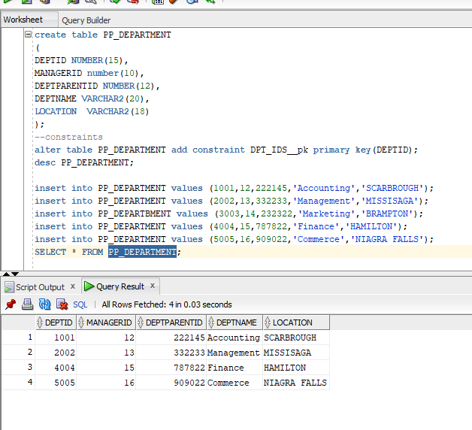

create table PP_DEPARTMENT

(

DEPTID NUMBER(15),

MANAGERID number(10),

DEPTPARENTID NUMBER(12),

DEPTNAME VARCHAR2(20),

LOCATION VARCHAR2(18)

);

--constraints

alter table PP_DEPARTMENT add constraint DPT_IDS__pk primary key(DEPTID);

desc PP_DEPARTMENT;

insert into PP_DEPARTMENT values (1001,12,222145,'Accounting','SCARBROUGH');

insert into PP_DEPARTMENT values (2002,13,332233,'Management','MISSISAGA');

insert into PP_DEPARTBMENT values (3003,14,232322,'Marketing','BRAMPTON');

insert into PP_DEPARTMENT values (4004,15,787822,'Finance','HAMILTON');

insert into PP_DEPARTMENT values (5005,16,909022,'Commerce','NIAGRA FALLS');

SELECT * FROM PP_DEPARTMENT;

Table name – Salary (Simranjeet)

|  |  |  |  |  |
| --- | --- | --- | --- | --- |
| **Attribute** | **Description** | **Key Type/**  **Constraint** | **Data Type** | **Field length** |
| salaryID | Unique identification for the ticket | Primary key | Number | 15 |
| empid | Used to login into the online system |  | Number | 10 |
| baseyear | Information update regarding the ticket |  | number | 12 |
| note | Number of the train |  | varchar2 | 60 |

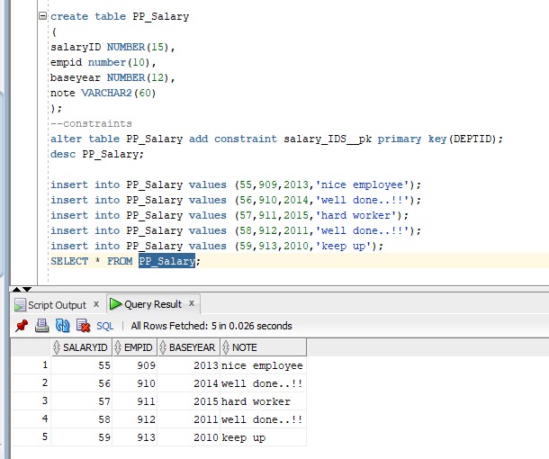

create table PP_Salary

(

salaryID NUMBER(15),

empid number(10),

baseyear NUMBER(12),

note VARCHAR2(60)

);

--constraints

alter table PP_Salary add constraint salary_IDS__pk primary key(DEPTID);

desc PP_Salary;

insert into PP_Salary values (55,909,2013,'nice employee');

insert into PP_Salary values (56,910,2014,'well done..!!');

insert into PP_Salary values (57,911,2015,'hard worker');

insert into PP_Salary values (58,912,2011,'well done..!!');

insert into PP_Salary values (59,913,2010,'keep up');

SELECT * FROM PP_Salary;

Table name – Bonus(Simranjeet)

|  |  |  |  |  |
| --- | --- | --- | --- | --- |
| Attribute | Description | Key Type/  Constraint | Data Type | Field length |
| user_id | Used to login into the online system | Primary Key | number | 10 |
| empid | First name of the user |  | Varchar2 | 15 |
| datebonus | Last name of the user |  | Varchar2 | 15 |
| bonuspayment | Male or female user |  | char | 1 |
| note | Age of the user |  | number | 3 |

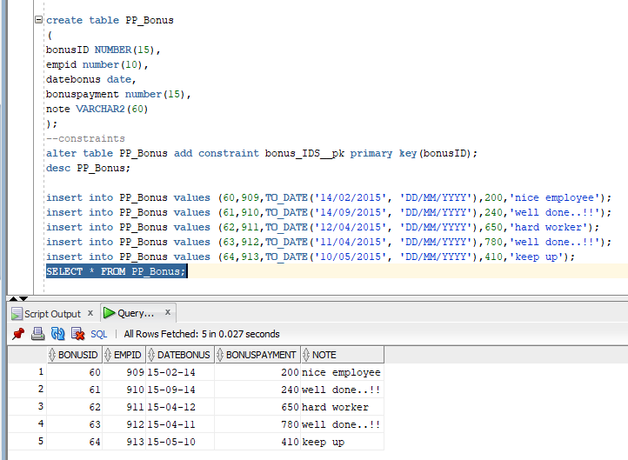

create table PP_Bonus

(

bonusID NUMBER(15),

empid number(10),

datebonus date,

bonuspayment number(15),

note VARCHAR2(60)

);

--constraints

alter table PP_Bonus add constraint bonus_IDS__pk primary key(bonusID);

desc PP_Bonus;

insert into PP_Bonus values (60,909,TO_DATE('14/02/2015', 'DD/MM/YYYY'),200,'nice employee');

insert into PP_Bonus values (61,910,TO_DATE('14/09/2015', 'DD/MM/YYYY'),240,'well done..!!');

insert into PP_Bonus values (62,911,TO_DATE('12/04/2015', 'DD/MM/YYYY'),650,'hard worker');

insert into PP_Bonus values (63,912,TO_DATE('11/04/2015', 'DD/MM/YYYY'),780,'well done..!!');

insert into PP_Bonus values (64,913,TO_DATE('10/05/2015', 'DD/MM/YYYY'),410,'keep up');

SELECT * FROM PP_Bonus;

Table name – Deductions(Simranjeet)

|  |  |  |  |  |
| --- | --- | --- | --- | --- |
| Attribute | Description | Key Type/  Constraint | Data Type | Field length |
| deducID | Used to login into the online system | Primary Key | number | 15 |
| empID | First name of the user |  | number | 10 |
| deductype | Last name of the user |  | number | 60 |
| amount | Male or female user |  | varchar | 15 |
| note | Age of the user |  | varchar2 | 60 |

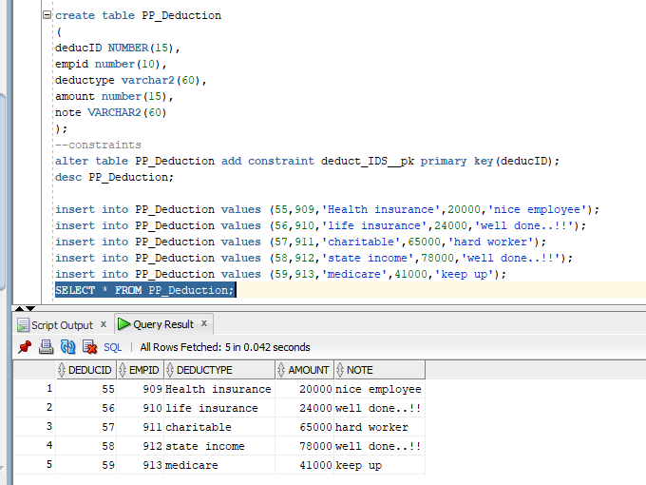

SELECT * FROM PP_Bonus;

create table PP_Deduction

(

deducID NUMBER(15),

empID number(10),

deductype NUMBER(60),

amount VARCHAR2(15),

note VARCHAR2(60)

);

--constraints

alter table PP_Deduction add constraint Deduc_IDS__pk primary key(DEPTID);

desc PP_Deduction;

insert into PP_Deduction values (55,909,'Health Insurance',20000,'nice employee');

insert into PP_Deduction values (56,910,'life insurance',24000,'well done..!!');

insert into PP_Deduction values (57,911,'charitable',65000,'hard worker');

insert into PP_Deduction values (58,912,'state income',78000,'well done..!!');

insert into PP_Deduction values (59,913,'medicare',41000,'keep up');

SELECT * FROM PP_Deduction;

Table name – JobTitle(Kelly)

|  |  |  |  |  |
| --- | --- | --- | --- | --- |
| **Attribute** | **Description** | **Key Type/**  **Constraint** | **Data Type** | **Field length** |
| JobId | Used to identify the job id | Primary key | Number | 5 |
| JobTitle | Used to identify the job title |  | Varchar2 | 50 |
| JobDesc | Used to understand the job |  | Varchar2 | 2000 |

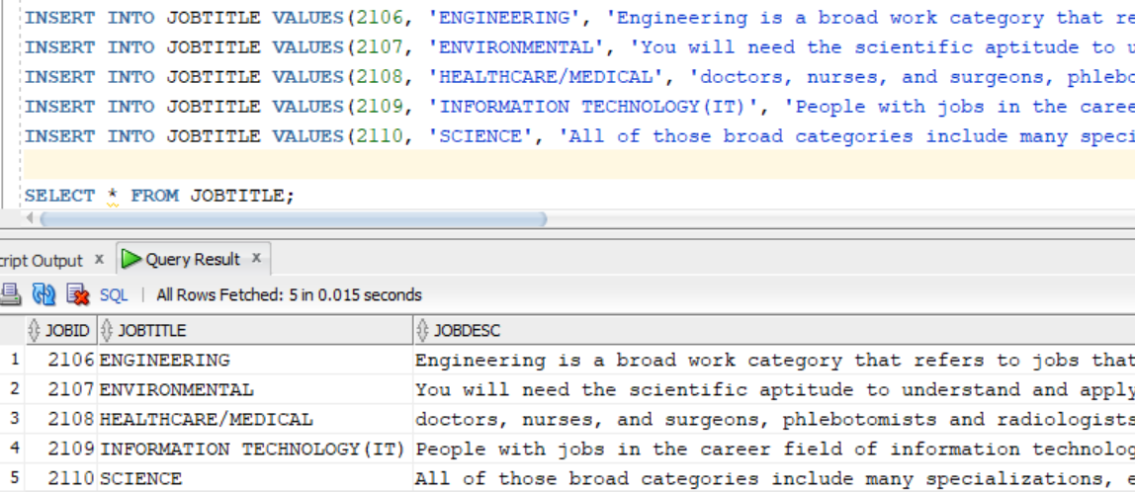

-- Create Job Title Table

CREATE TABLE JOBTITLE (

JOBID NUMBER(5),

JOBTITLE VARCHAR2(50),

JOBDESC VARCHAR2(2000),

CONSTRAINT JOBTITLE_ID_PK PRIMARY KEY(JOBID)

);

--inserting data

INSERT INTO JOBTITLE VALUES(2106, 'ENGINEERING', 'Engineering is a broad work category that refers to jobs that use science and mathematics to solve a variety of problems.');

INSERT INTO JOBTITLE VALUES(2107, 'ENVIRONMENTAL', 'You will need the scientific aptitude to understand and apply complex concepts in biology, chemistry, geology, and physics and will learn to apply both quantitative and qualitative analytical skills to solving problems and interpreting research data.');

INSERT INTO JOBTITLE VALUES(2108, 'HEALTHCARE/MEDICAL', 'doctors, nurses, and surgeons, phlebotomists and radiologists.');

INSERT INTO JOBTITLE VALUES(2109, 'INFORMATION TECHNOLOGY(IT)', 'People with jobs in the career field of information technology (IT) use computers, software, networks, servers, and other technology to manage and store data.');

INSERT INTO JOBTITLE VALUES(2110, 'SCIENCE', 'All of those broad categories include many specializations, each with its own set of technical skills, knowledge, and educational requirements.');

SELECT * FROM JOBTITLE;

Table name – EmployeeType(Kelly)

|  |  |  |  |  |
| --- | --- | --- | --- | --- |
| **Attribute** | **Description** | **Key Type/**  **Constraint** | **Data Type** | **Field length** |
| TypeId | Used to identify the type id | Primary key | Number | 5 |
| TypeName | used to identify the type name |  | Varchar2 | 50 |
| TypeDesc | used to understand the type |  | Varchar2 | 2000 |

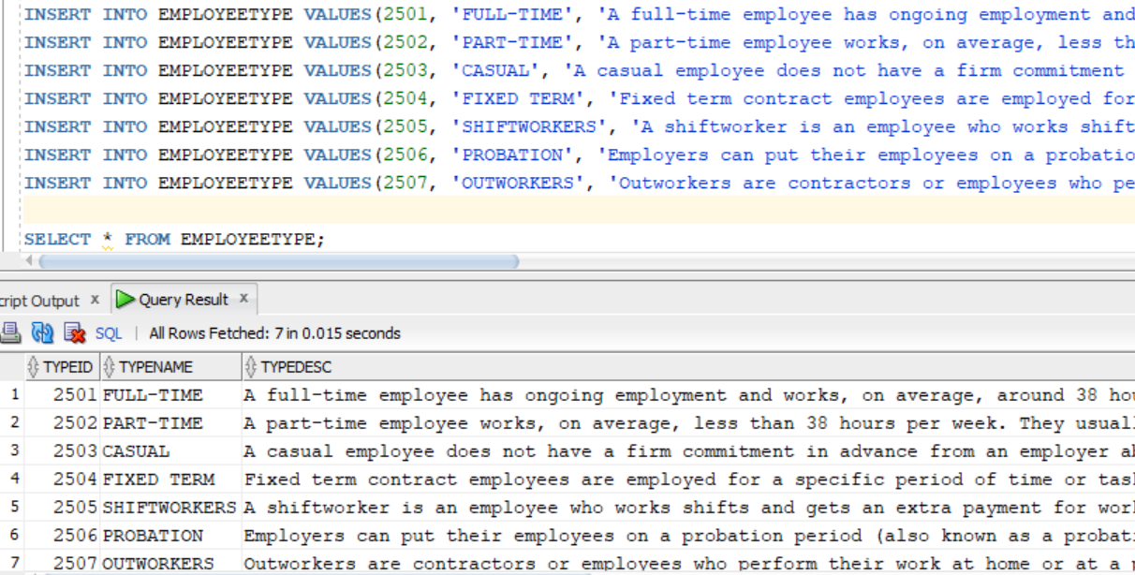

-- Create Employee Type Table

CREATE TABLE EMPLOYEETYPE (

TYPEID NUMBER(5),

TYPENAME VARCHAR2(50),

TYPEDESC VARCHAR2(2000),

CONSTRAINT EMPTYPE_ID_PK PRIMARY KEY(TYPEID)

);

DROP TABLE EMPLOYEETYPE;

INSERT INTO EMPLOYEETYPE VALUES(2501, 'FULL-TIME', 'A full-time employee has ongoing employment and works, on average, around 38 hours each week. The actual hours of work for an employee in a particular job or industry are agreed between the employer and the employee and/or set by an award or registered agreement.');

INSERT INTO EMPLOYEETYPE VALUES(2502, 'PART-TIME', 'A part-time employee works, on average, less than 38 hours per week. They usually work regular hours each week and is entitled to the same benefits as a full-time employee, but on a pro rata basis. They are a permanent employee or on a fixed-term contract.');

INSERT INTO EMPLOYEETYPE VALUES(2503, 'CASUAL', 'A casual employee does not have a firm commitment in advance from an employer about how long they will be employed for, or the days (or hours) they will work. A casual employee also does not commit to all work an employer might offer.');

INSERT INTO EMPLOYEETYPE VALUES(2504, 'FIXED TERM', 'Fixed term contract employees are employed for a specific period of time or task. For example a 6 month contract where employment ends after 6 months.');

INSERT INTO EMPLOYEETYPE VALUES(2505, 'SHIFTWORKERS', 'A shiftworker is an employee who works shifts and gets an extra payment for working shift hours.');

INSERT INTO EMPLOYEETYPE VALUES(2506, 'PROBATION', 'Employers can put their employees on a probation period (also known as a probationary period) to assess if employees are suitable for the role and business.');

INSERT INTO EMPLOYEETYPE VALUES(2507, 'OUTWORKERS', 'Outworkers are contractors or employees who perform their work at home or at a place that wouldn’t normally be thought of as a business premises. Outworkers are common in the textile, clothing or footwear industry.');

SELECT * FROM EMPLOYEETYPE;

Table name – EmpCategory (Kelly)

|  |  |  |  |  |
| --- | --- | --- | --- | --- |
| **Attribute** | **Description** | **Key Type/**  **Constraint** | **Data Type** | **Field length** |
| CatId | used to identify the category id | Primary key | Number | 5 |
| CatName | used to identify the category name |  | Varchar2 | 50 |
| CatDesc | used to understand the category |  | Varchar2 | 2000 |

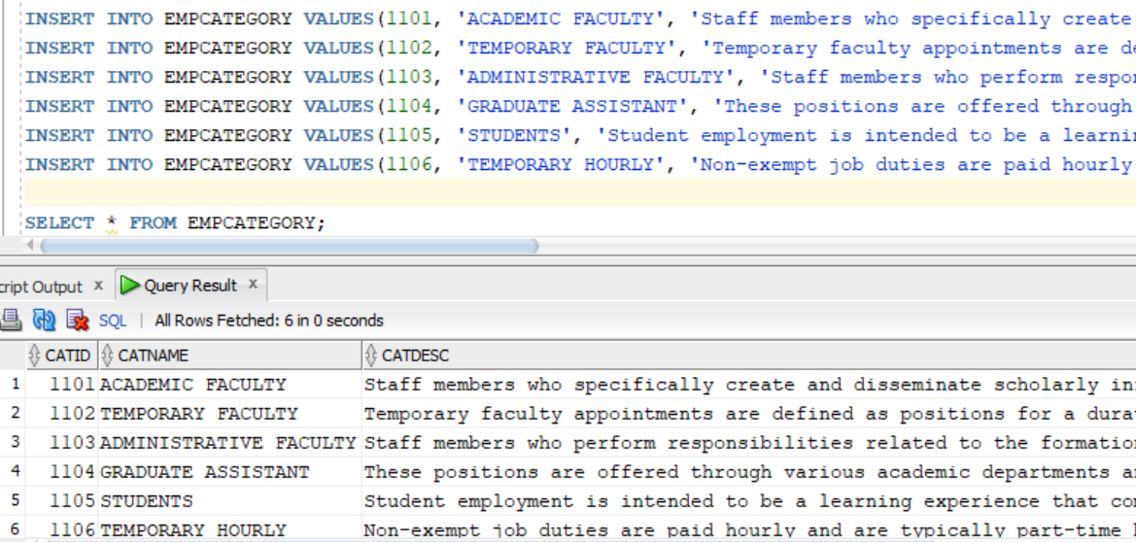

-- Create Employee Category Table

CREATE TABLE EMPCATEGORY (

CATID NUMBER(5),

CATNAME VARCHAR2(50),

CATDESC VARCHAR2(2000),

CONSTRAINT EMPCAT_ID_PK PRIMARY KEY(CATID)

);

INSERT INTO EMPCATEGORY VALUES(1101, 'ACADEMIC FACULTY', 'Staff members who specifically create and disseminate scholarly information through teaching, research and library services.');

INSERT INTO EMPCATEGORY VALUES(1102, 'TEMPORARY FACULTY', 'Temporary faculty appointments are defined as positions for a duration of one year or less.');

INSERT INTO EMPCATEGORY VALUES(1103, 'ADMINISTRATIVE FACULTY', 'Staff members who perform responsibilities related to the formation and implementation of managerial policies or general operations of the university.');

INSERT INTO EMPCATEGORY VALUES(1104, 'GRADUATE ASSISTANT', 'These positions are offered through various academic departments and are paid by grants or state funds.');

INSERT INTO EMPCATEGORY VALUES(1105, 'STUDENTS', 'Student employment is intended to be a learning experience that complements a student’s academic and career goals and provides valuable work experience.');

INSERT INTO EMPCATEGORY VALUES(1106, 'TEMPORARY HOURLY', 'Non-exempt job duties are paid hourly and are typically part-time but may be full-time for a few months.');

SELECT * FROM EMPCATEGORY;

**SQL code for generating table and QUERIES:**

**Queries (by --**KELLY---**)**

**-- FIND NUMBER OF DATA OF EACH PROJECT ID**

SELECT PROJECTID, COUNT(*) FROM PP_TIMESEET GROUP BY PROJECTID;

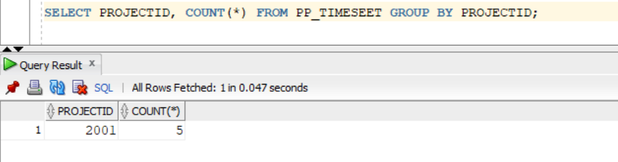

-- **USING JOIN TO DISPLAY THE BONUS ID FROM EMP ID WITH FIRST NAME AS KELLY**

SELECT FIRSTNAME, LASTNAME, BONUSID, DATEBONUS FROM PP_EMPLOYEE

JOIN PP_BONUS USING(EMPID)

WHERE EMPID = (SELECT EMPID FROM PP_EMPLOYEE

WHERE EMPID = 909);

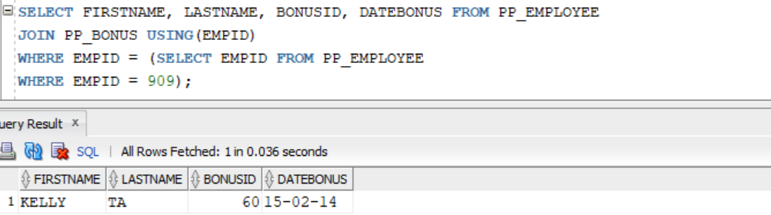

**-- TO FIND EMPID WHERE DEDUCID = 570 IN A PL/SQL BLOCK**

SET SERVEROUTPUT ON;

DECLARE

LV_EMPID PP_DEDUCTION.EMPID%TYPE;

BEGIN

SELECT EMPID INTO LV_EMPID FROM PP_DEDUCTION WHERE DEDUCID = 570;

DBMS_OUTPUT.PUT_LINE(LV_EMPID);

END;

/

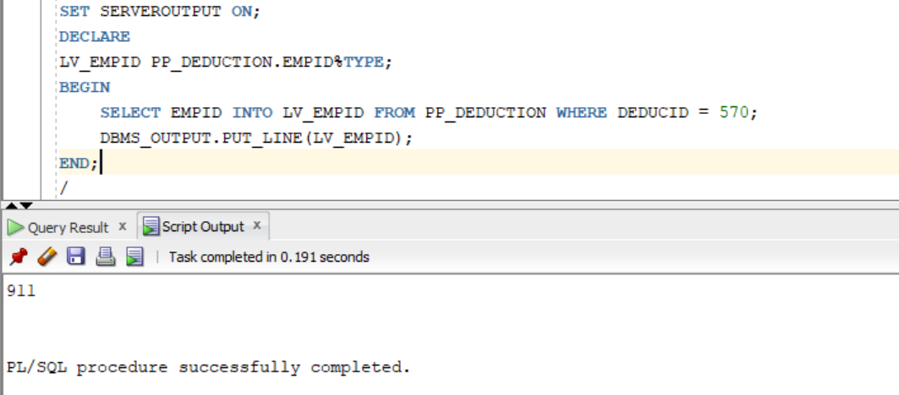

**-- DISPLAY JOBID AND JOB DESCRIPTION WHERE JOB ID = 2109 USING PL/SQL BLOCK %ROWTYPE**

SET SERVEROUTPUT ON;

DECLARE

L_JOBTITLE JOBTITLE%ROWTYPE;

BEGIN

SELECT * INTO L_JOBTITLE

FROM JOBTITLE WHERE JOBID = 2109;

DBMS_OUTPUT.PUT_LINE(L_JOBTITLE.JOBID || ', ' || L_JOBTITLE.JOBDESC);

END;

/

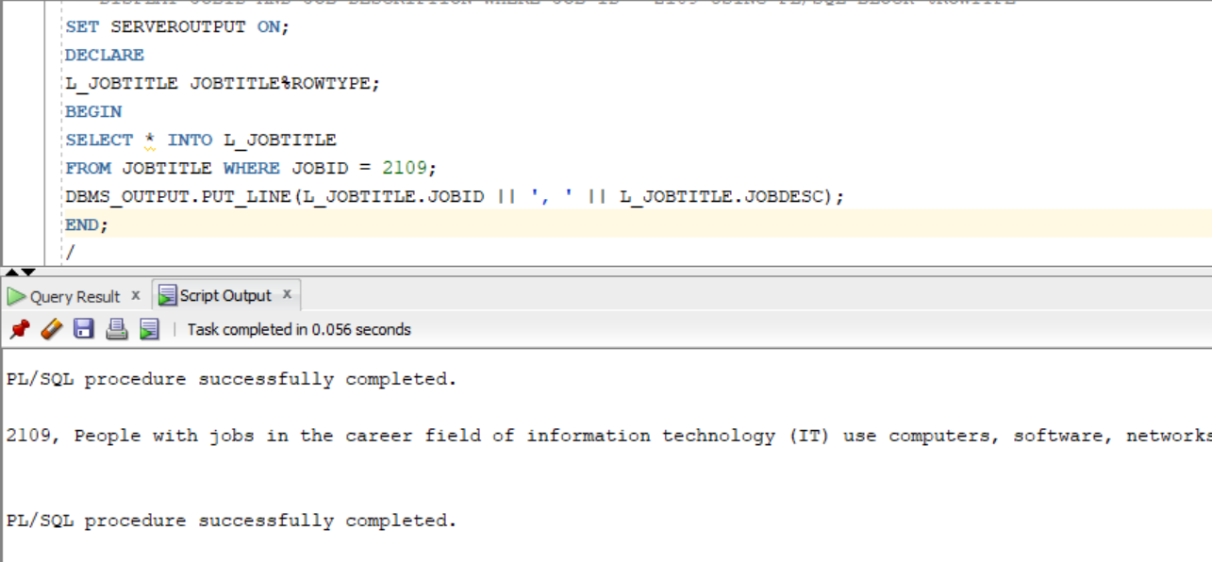

**-- DISPLAY EMPLOYEE ID, PAYROLL ID AND START DATE USING CURSOR IN PL/SQL BLOCK**

SET SERVEROUTPUT ON;

DECLARE

C_EMPID NUMBER(5);

C_PAYROLLID NUMBER(5);

C_STARTDATE DATE;

CURSOR C_PAYROLL IS

SELECT EMPID, PAYROLLID, STARTDATE FROM PP_PAYROLL;

BEGIN

OPEN C_PAYROLL;

LOOP

FETCH C_PAYROLL INTO C_EMPID, C_PAYROLLID, C_STARTDATE;

EXIT WHEN C_PAYROLL%NOTFOUND;

DBMS_OUTPUT.PUT_LINE(C_EMPID || ', ' || C_PAYROLLID || ', ' || C_STARTDATE);

END LOOP;

CLOSE C_PAYROLL;

END;

/

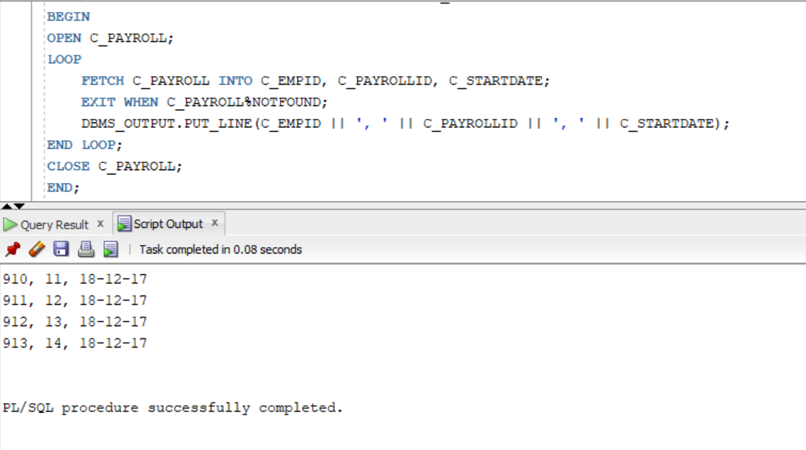

-**- PACKAGE TO FIND EMPLOYEE TYPE**

CREATE OR REPLACE PACKAGE EMPLOYEE_TYPE AS

PROCEDURE FIND_EMPLOYEE

(P_TYPEID IN NUMBER,

P_TYPENAME OUT VARCHAR2,

P_TYPEDESC OUT VARCHAR2);

END EMPLOYEE_TYPE;

/

--**PACKAGE BODY**

CREATE OR REPLACE PACKAGE BODY EMPLOYEE_TYPE AS

PROCEDURE FIND_EMPLOYEE

(P_TYPEID IN NUMBER,

P_TYPENAME OUT VARCHAR2,

P_TYPEDESC OUT VARCHAR2)

AS

BEGIN

SELECT TYPENAME, TYPEDESC INTO P_TYPENAME, P_TYPEDESC FROM EMPLOYEETYPE

WHERE TYPEID = P_TYPEID;

DBMS_OUTPUT.PUT_LINE('TYPE NAME: ' || P_TYPENAME);

DBMS_OUTPUT.PUT_LINE('TYPE DESC: ' || P_TYPEDESC);

EXCEPTION

WHEN NO_DATA_FOUND THEN

DBMS_OUTPUT.PUT_LINE('INVALID TYPE ID');

END FIND_EMPLOYEE;

END EMPLOYEE_TYPE;

/

-- **TESTING PACKAGE**

SET SERVEROUTPUT ON;

DECLARE

LV_NAME VARCHAR2(50);

LV_DESC VARCHAR2(2000);

BEGIN

EMPLOYEE_TYPE.FIND_EMPLOYEE(&ID, LV_NAME, LV_DESC);

END;

/

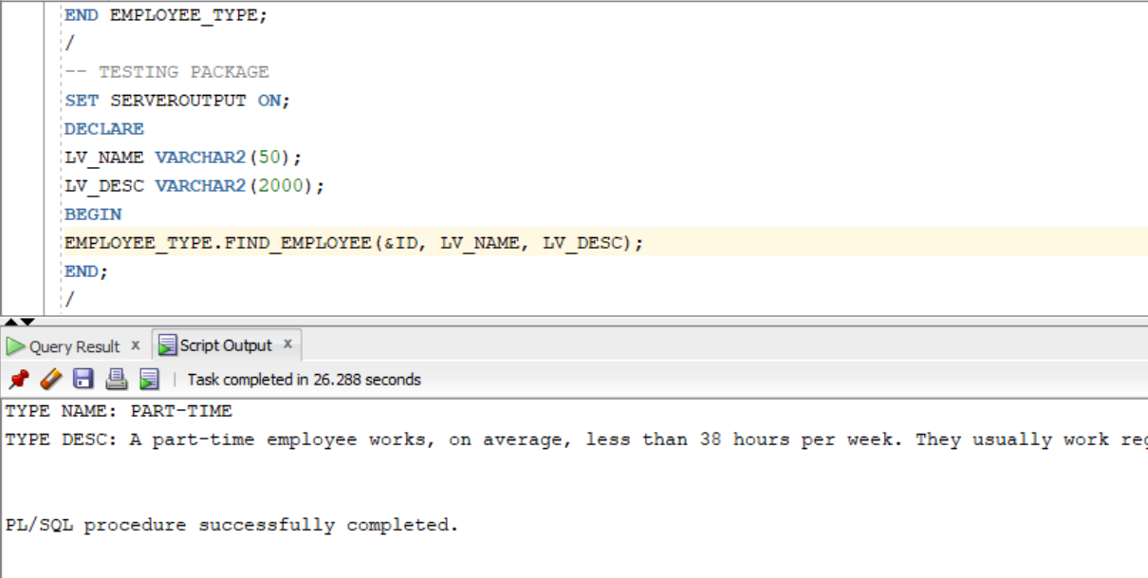

**Queries (by --**Simran---**)**

1. Sequences:

(to add departmentId into pp_department table in new row using nextvalue)

---------------SEQ (using sequence to add departmentId)

CREATE SEQUENCE PP_SEQ_SIMRAN

START WITH 7007

INCREMENT BY 1000

MINVALUE 1001 MAXVALUE 100000

CYCLE CACHE 2 ORDER; --FOR MAKING A CYCLE IN TWO COMPLETE REPEITION

-------------COMBINING

INSERT INTO PP_DEPARTMENT (DEPTID , MANAGERID) VALUES ( PP_SEQ_SIMRAN.NEXTVAL , 18);

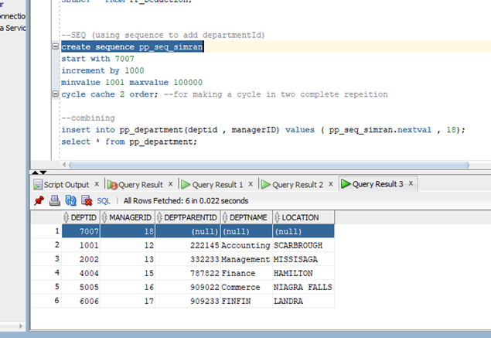

2.) Views

(To check for payment having less than $500 bonus)

-------views

CREATE OR REPLACE VIEW BONUS_MERGED AS

SELECT * FROM PP_BONUS

WHERE BONUSPAYMENT < 500

WITH READ ONLY CONSTRAINT BONUS_ADDED_COSNT;

SELECT * FROM BONUS_MERGED;

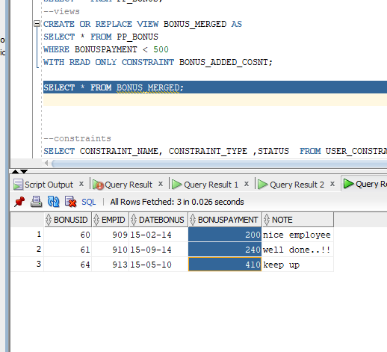

3. Viewing constraints in tables

SELECT CONSTRAINT_NAME, CONSTRAINT_TYPE ,STATUS FROM USER_CONSTRAINTS WHERE TABLE_NAME IN ('pp_department');

4. Indexes

(to identify the deptid by firstname from pp_employee)

SELECT * FROM PP_EMPLOYEE;

CREATE INDEX IND_DEPT_NAME ON PP_EMPLOYEE(DEPID,FIRSTNAME);

SELECT DEPID,FIRSTNAME FROM PP_EMPLOYEE WHERE DEPID = 2002 AND FIRSTNAME = 'jOHN';

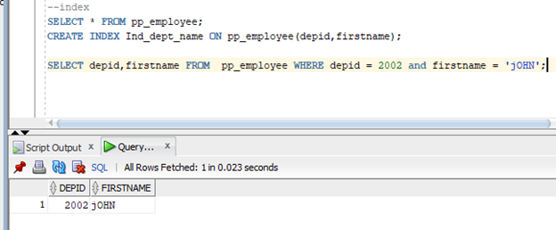

5. pl/sql command {anchor} (TO print payroll information using few variable)

SET SERVEROUTPUT ON;

DECLARE

LV_PAYROLLID PP_PAYROLL.PAYROLLID%TYPE;

LV_EMPID PP_PAYROLL.EMPID%TYPE;

LV_GROSSPAY PP_PAYROLL.GROSSPAY%TYPE;

BEGIN

SELECT PAYROLLID , EMPID, GROSSPAY

INTO LV_PAYROLLID, LV_EMPID,LV_GROSSPAY

FROM PP_PAYROLL WHERE SALARYID = '56';

DBMS_OUTPUT.PUT_LINE(LV_PAYROLLID);

DBMS_OUTPUT.PUT_LINE(LV_EMPID);

DBMS_OUTPUT.PUT_LINE(LV_GROSSPAY);

END;

/

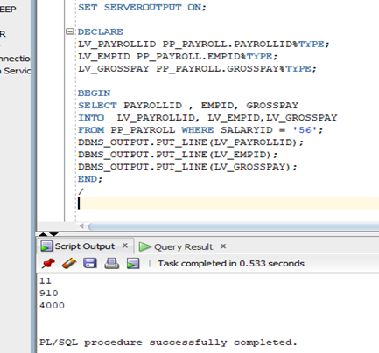

6. Deleting and handling exception

SELECT * FROM PP_DEPARTMENT;

SET SERVEROUTPUT ON;

BEGIN

DELETE FROM PP_DEPARTMENT WHERE DEPTID = 7007 ;

IF SQL%NOTFOUND THEN

DBMS_OUTPUT.PUT_LINE('ROW NOT FOUND- DELETION FAILED');

ELSE

DBMS_OUTPUT.PUT_LINE(SQL%ROWCOUNT || 'ROWS DELETED ');

END IF;

END;

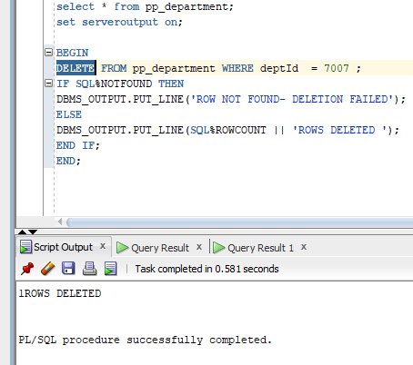

7. Cursor {IMPLICIT METHOD}

SET SERVEROUTPUT ON;

DECLARE

LV_PAYROLLID PP_PAYROLL.PAYROLLID%TYPE;

LV_EMPID PP_PAYROLL.EMPID%TYPE;

LV_GROSSPAY PP_PAYROLL.GROSSPAY%TYPE;

CURSOR C12 IS

SELECT PAYROLLID , EMPID, GROSSPAY FROM PP_PAYROLL;

BEGIN

OPEN C12;

LOOP

FETCH C12 INTO LV_PAYROLLID, LV_EMPID,LV_GROSSPAY;

EXIT WHEN C12%NOTFOUND;

DBMS_OUTPUT.PUT_LINE('ID: ' || LV_PAYROLLID || ' ' ||

'EMP ID: '|| LV_EMPID || ' ' || 'GROSS: ' || LV_GROSSPAY );

END LOOP;

CLOSE C12;

END;

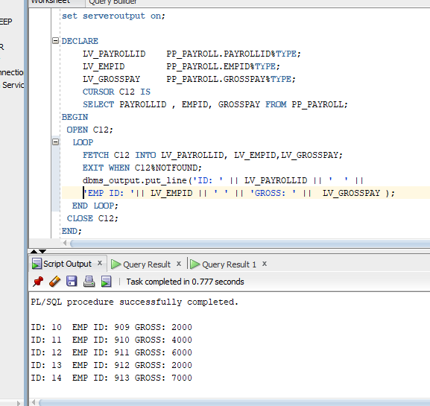

8.) PROCEDURE

CREATE OR REPLACE PROCEDURE MY_PAYROLL_PRODEDURE IS --PROCEDURE

CURSOR C11 IS ---------------USING CURSOR

select * FROM PP_SALARY;

R_CUR C11%ROWTYPE;

BEGIN

OPEN C11;

DBMS_OUTPUT.PUT('CUSTOMER'||' '||'CITY');

LOOP

FETCH C11 INTO R_CUR;

EXIT WHEN C11%NOTFOUND;

DBMS_OUTPUT.PUT_LINE(R_CUR.SALARYID||' '||R_CUR.BASEYEAR);

END LOOP;

CLOSE C11;

END;

/

DESC PROCEDURE my_pAYROLL_PRODEDURE;

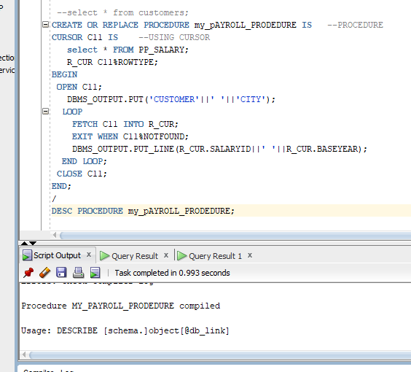

9.) Package

I.) PACKAGE HAVING CURSOR

--Declaring the cursor in package

CREATE OR REPLACE PACKAGE employee_pay_pkg IS

CURSOR emp_cur IS --USING CURSOR

select * FROM PP_SALARY;

R1_CUR emp_cur%ROWTYPE;

end;

/

SET SERVEROUTPUT ON;

create or replace package body employee_pay_pkg is

procedure EMP_PRO is

R1_CUR emp_cur%ROWTYPE;

begin

open emp_cur;

loop

fetch emp_cur into R1_CUR;

exit when emp_cur%NOTFOUND;

DBMS_OUTPUT.put_line(R1_CUR.SALARYID);

end loop;

close emp_cur;

end;

end;

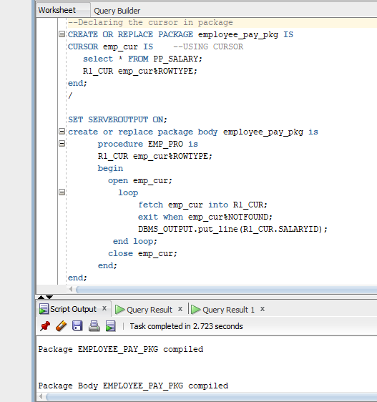

10.) TRIGGERS (SIMPLE)

CREATE OR REPLACE TRIGGER pay_trig

AFTER INSERT OR DELETE OR UPDATE ON PP_payroll

FOR EACH ROW

BEGIN

if inserting then

update pp_salary set SALARYID =: New.SALARYID where ;EMPID = :new.EMPID

elsif

UPDATING THEN

update pp_salary set SALARYID =: New.SALARYID where ;EMPID = :new.EMPID

end if;

END;

/

UPDATE PP_payroll set salaryid = 33 where empid = 909;

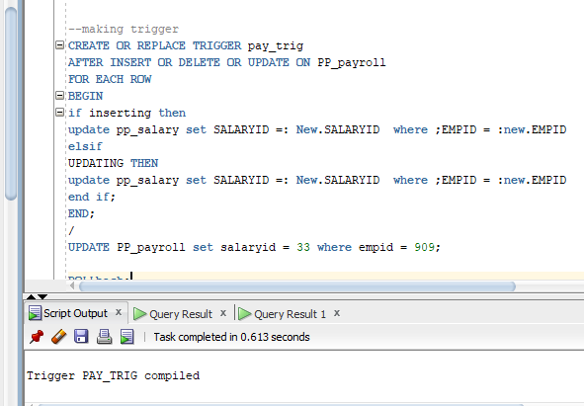

**Queries (by --**TARIQ---**)**

**--PACKAGE SPECIFICATION-------**

create OR REPLACE PACKAGE EMP_QUERY_PKG IS

PROCEDURE EMP_INFO_PP

(P_ID IN PP_EMPLOYEE.EMPID%TYPE,

P_FIRSTNAME OUT PP_EMPLOYEE.FIRSTNAME%TYPE,

P_CITY OUT PP_EMPLOYEE.CITY%TYPE,

P_STATE OUT PP_EMPLOYEE.STATE%TYPE);

PROCEDURE EMP_INFO_PP

(P_ID IN PP_EMPLOYEE.LASTNAME%TYPE,

P_FIRSTNAME OUT PP_EMPLOYEE.FIRSTNAME%TYPE,

P_CITY OUT PP_EMPLOYEE.CITY%TYPE,

P_STATE OUT PP_EMPLOYEE.STATE%TYPE);

END;

/

SELECT * FROM PP_EMPLOYEE;

**--CREATING THE PACKAGE BODY--------------------**

CREATE OR REPLACE PACKAGE BODY EMP_QUERY_PKG IS

PROCEDURE EMP_INFO_PP

(P_ID IN PP_EMPLOYEE.EMPID%TYPE,

P_FIRSTNAME OUT PP_EMPLOYEE.FIRSTNAME%TYPE,

P_CITY OUT PP_EMPLOYEE.CITY%TYPE,

P_STATE OUT PP_EMPLOYEE.STATE%TYPE)

IS

BEGIN

SELECT FIRSTNAME, CITY, STATE INTO P_FIRSTNAME, P_CITY, P_STATE

FROM PP_EMPLOYEE

WHERE EMPID = P_ID ;

EXCEPTION

WHEN NO_DATA_FOUND THEN

DBMS_OUTPUT.PUT_LINE('ID DOES NOT EXIST');

END;

PROCEDURE EMP_INFO_PP

(P_ID IN PP_EMPLOYEE.LASTNAME%TYPE,

P_FIRSTNAME OUT PP_EMPLOYEE.FIRSTNAME%TYPE,

P_CITY OUT PP_EMPLOYEE.CITY%TYPE,

P_STATE OUT PP_EMPLOYEE.STATE%TYPE)

IS

BEGIN

SELECT FIRSTNAME, CITY, STATE INTO P_FIRSTNAME, P_CITY, P_STATE

FROM PP_EMPLOYEE

WHERE LASTNAME= P_ID;

EXCEPTION

WHEN NO_DATA_FOUND THEN

DBMS_OUTPUT.PUT_LINE('LASTNAME DOES NOT FOUND');

END;

END;

/

**--TESTING THE PACKAGE------------------------**

**--FIRST ATTEMPT-----------------------------------------**

DECLARE

LV_ID_NUM PP_EMPLOYEE.EMPID%TYPE :=&EMPLOYEE_ID;

LV_FIRSTNAME_TXT PP_EMPLOYEE.FIRSTNAME%TYPE;

LV_CITY_TXT PP_EMPLOYEE.CITY%TYPE;

LV_STATE_TXT PP_EMPLOYEE.STATE%TYPE;

BEGIN

EMP_QUERY_PKG.EMP_INFO_PP (LV_ID_NUM, LV_FIRSTNAME_TXT, LV_CITY_TXT, LV_STATE_TXT);

DBMS_OUTPUT.PUT_LINE('FIRST NAME ' ||LV_FIRSTNAME_TXT);

DBMS_OUTPUT.PUT_LINE('CITY '||LV_CITY_TXT);

DBMS_OUTPUT.PUT_LINE('STATE '||LV_STATE_TXT);

END;

/

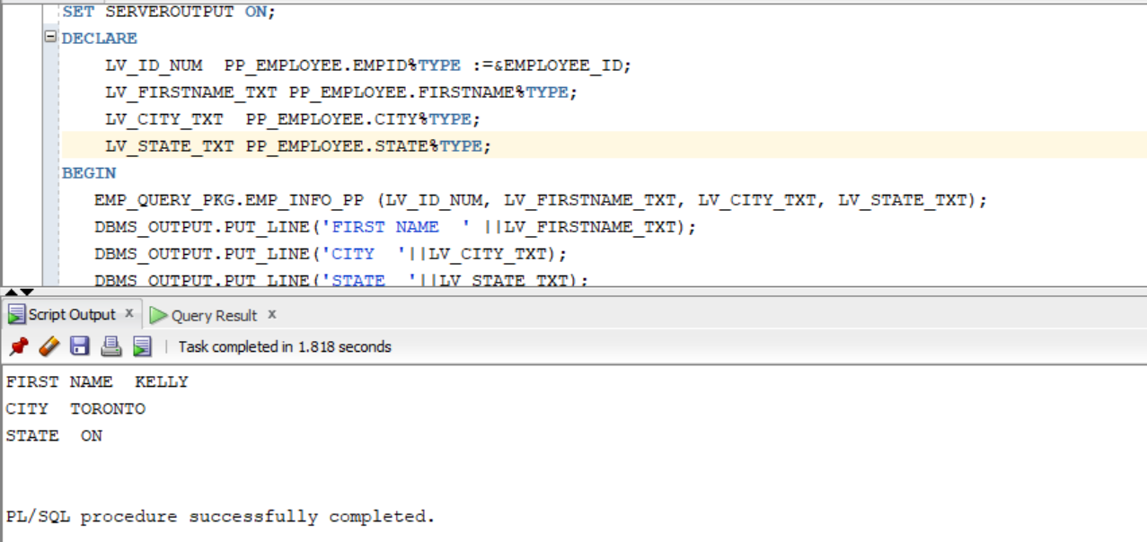

SET SERVEROUTPUT ON;

CREATE OR REPLACE FUNCTION DISPLAYNAME

RETURN varchar2

IS

c_ID pp_employee.empid%type;

c_FIRST pp_employee.firstname%type;

c_LASTNAME pp_employee.lastname%type;

BEGIN

SELECT FIRSTNAME,LASTNAME

INTO

c_FIRST,c_LASTNAME

FROM PP_EMPLOYEE

where EMPID = &EMPLOYEE_NUMBER ;

return ('FIRST_NAME:'|| ' ' || c_FIRST || ' ' || 'LAST_NAME:' || ' ' || c_LASTNAME);

END;

/

select displayname from dual;

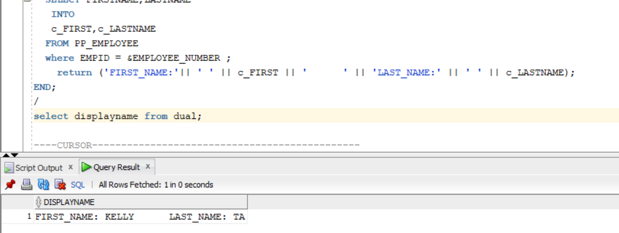

**----CURSOR----------------------------------------------**

SET SERVEROUTPUT ON;

DECLARE

TYPE type_EMPLOYEE is TABLE OF PP_EMPLOYEE%ROWTYPE

INDEX BY PLS_INTEGER;

C1 type_EMPLOYEE ;

begin

select * BULK COLLECT into C1

from PP_EMPLOYEE where EMPID=&n;

FOR I IN 1.. C1.count loop

DBMS_OUTPUT.PUT_LINE(C1(i).firstname || C1(i).LASTNAME);

END LOOP;

END;

/

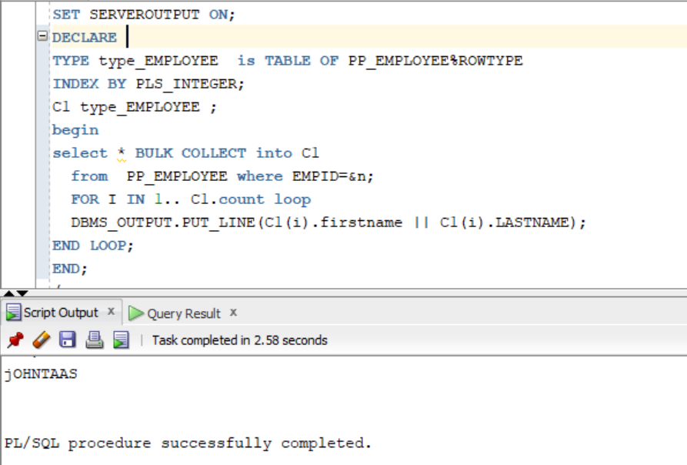

**-- cursor based record variable**

set serveroutput on;

Declare

CURSOR C1 IS

SELECT EMPID,FIRSTNAME FROM PP_EMPLOYEE

WHERE EMPID>909;

var_cus c1%rowtype;

BEGIN

OPEN C1;

LOOP

FETCH C1 INTO var_cus;

EXIT WHEN C1%NOTFOUND;

DBMS_OUTPUT.PUT_LINE(var_cus.EMPID||' '||var_cus.firstname);

END LOOP;

CLOSE C1;

END;

/

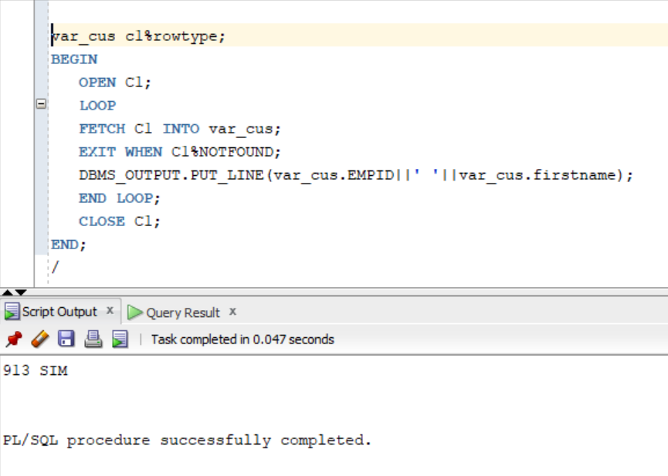

**--TRIGGER FOR EMPLOYEE----**

CREATE OR REPLACE TRIGGER EMP_ONE_trg

AFTER UPDATE OF SSN ON EMP_EMPLOYEE

BEGIN

DBMS_OUTPUT.PUT_LINE('TRIGGER NUMBER 1 IS FIRED!');

END;

create or replace

trigger EMP_TWO_trg

AFTER UPDATE OF SSN ON PP_EMPLOYEE

FOLLOWS EMP_ONE_trg

BEGIN

DBMS_OUTPUT.PUT_LINE('TRIGGER NUMBER TWO IS FIRED!');

END;

/

**-- CHECK DBMS OUTPUT**

UPDATE PP_EMPLOYEE

set SSN=&SIN_NUMBER

where EMPID=909;

SELECT * FROM PP_EMPLOYEE;

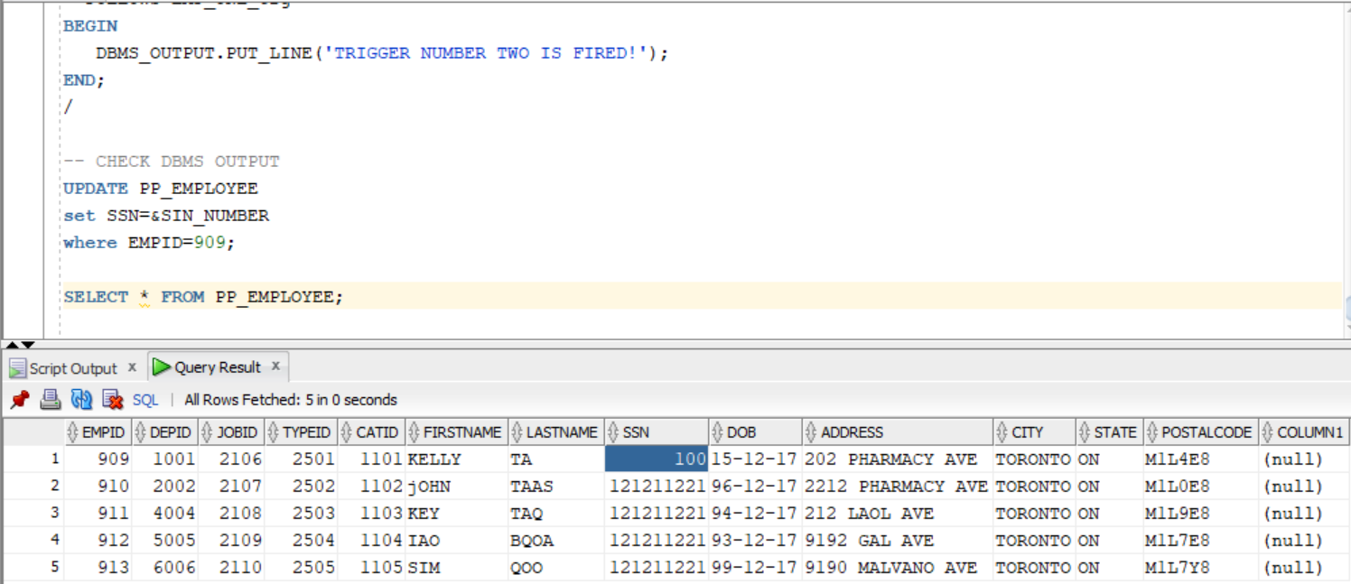

**TO DISPLAY TABLE CONTENT**

SELECT * FROM EMPCATEGORY;

SELECT * FROM EMPLOYEETYPE;

SELECT * FROM JOBTITLE;

SELECT * FROM PP_BONUS;

SELECT * FROM PP_DEDUCTION;

SELECT * FROM PP_DEPARTMENT;

SELECT * FROM PP_EMPLOYEE;

SELECT * FROM PP_PAYROLL;

SELECT * FROM PP_SALARY;

SELECT * FROM PP_TIMESEET;

**DROPPING THE TABLES**

DROP TABLE PP_EMPLOYEE CASCADE CONSTRAINTS;

DROP TABLE PP_PAYROLL CASCADE CONSTRAINTS;

DROP TABLE PP_TIMESEET CASCADE CONSTRAINTS;

DROP TABLE PP_BONUS CASCADE CONSTRAINTS;

DROP TABLE PP_DEPARTMENT CASCADE CONSTRAINTS;

DROP TABLE PP_DEDUCTION CASCADE CONSTRAINTS;

DROP TABLE PP_SALARY CASCADE CONSTRAINTS;

DROP TABLE EMPLOYEETYPE CASCADE CONSTRAINTS;

DROP TABLE JOBTITLE CASCADE CONSTRAINTS;

DROP TABLE EMPCATEGORY CASCADE CONSTRAINTS;

**DESCRIBING THE TABLE**

DESC PP_EMPLOYEE;

DESC PP_PAYROLL;

DESC PP_TIMESEET;

DESC PP_BONUS;

DESC PP_DEPARTMENT;

DESC PP_DEDUCTION;

DESC PP_SALARY;

DESC EMPLOYEETYPE;

DESC EMPCATEGORY;

DESC JOBTITLE;

**DISPLAYING CONSTRAINTS**

SELECT * FROM user_constraints WHERE table_name = 'PP_EMPLOYEE';

SELECT * FROM user_constraints WHERE table_name = 'PP_PAYROLL';

SELECT * FROM user_constraints WHERE table_name = 'PP_TIMESEET';

SELECT * FROM user_constraints WHERE table_name = 'PP_BONUS';

SELECT * FROM user_constraints WHERE table_name = 'PP_DEPARTMENT';

SELECT * FROM user_constraints WHERE table_name = 'PP_DEDUCTION';

SELECT * FROM user_constraints WHERE table_name = 'PP_SALARY';

SELECT * FROM user_constraints WHERE table_name = 'EMPLOYEETYPE';

SELECT * FROM user_constraints WHERE table_name = 'EMPCATEGORY';

SELECT * FROM user_constraints WHERE table_name = 'JOBTITLE';

**X*********************************************************************************************************X**